Approach for Effective Design and Cost Estimation of New build / Conversion FPSO

Author name(s): Upendra. Malla¹ (M); Krishna M. Karri² (M)
1. Granherne - A KBR Company
2. Technology Associates Inc.

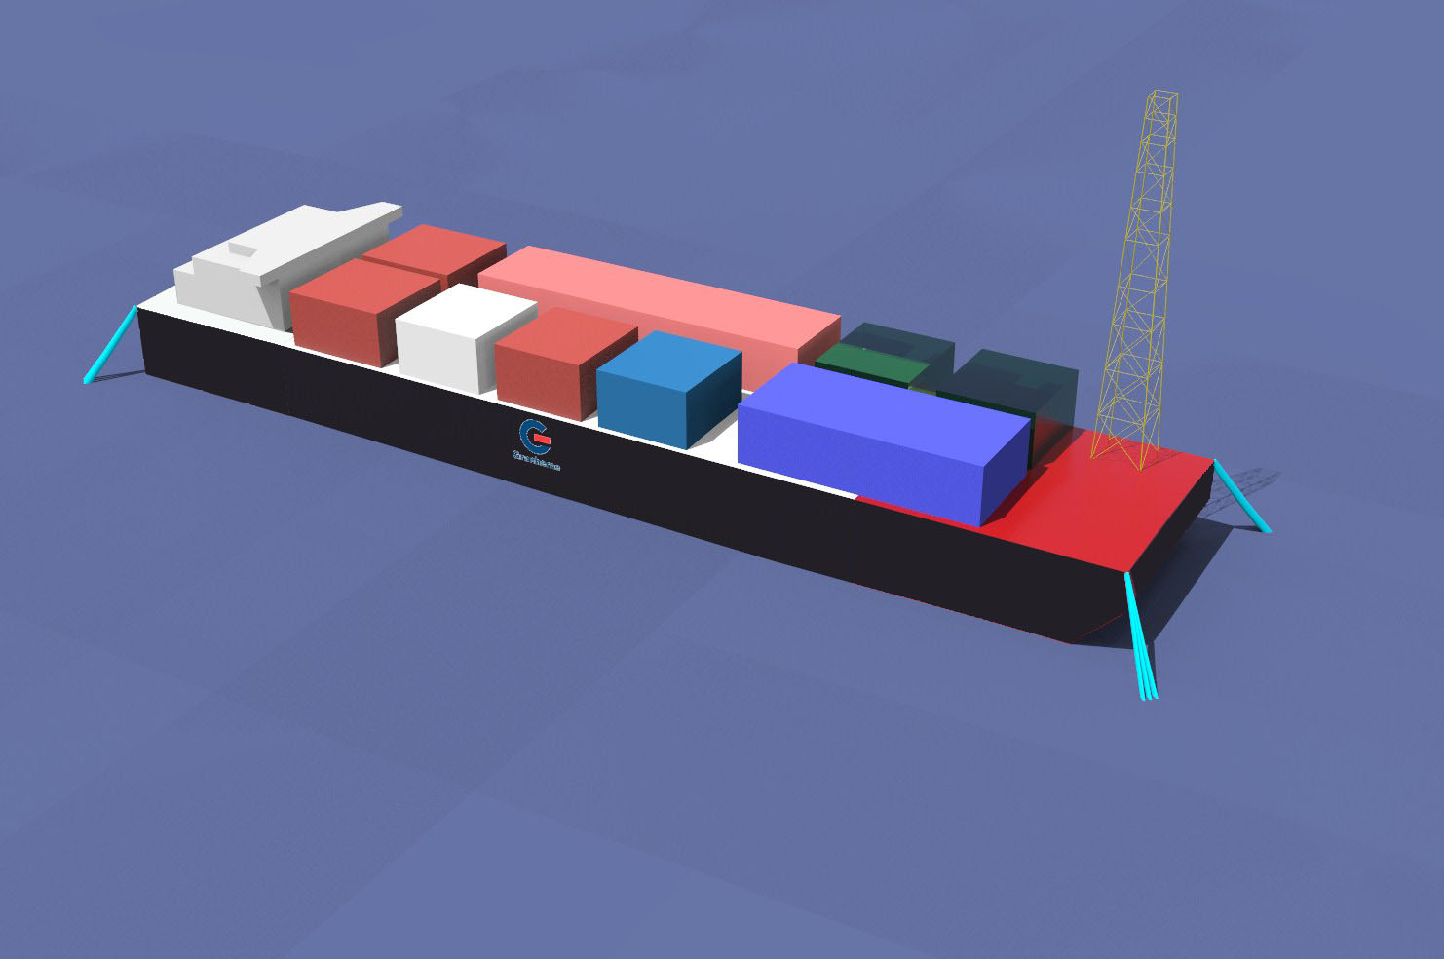

Floating Production Storage and Offloading (FPSO) sizing and cost estimation has become a challenging task at the early stages of offshore field development. During the early stages of field development designer needs to size and estimate cost in order to decide feasibility of the project. This paper describes a step by step method used to size and estimate the cost of a new built (or) converted FPSO based on basic engineering, existing FPSO data and corresponding metocean criteria for a particular location. This step by step approach covers FPSO sizing, hull structural design, mooring sizing, topsides support design and steel renewal using offshore classification rules and regulations. FPSO cost is estimated based on the design particulars (i.e. hull weights, FPSO particulars, mooring sizes etc.) and current market unit rates. This approach is an effective means to size and estimate cost of an FPSO at early stages of field development which saves overall time and cost for a client.

KEY WORDS: FPSO; Field Development; Hull; Mooring; Turret; Cost; Estimatio

NOMENCLATURE
A_{x} = Acceleration in Surge Motion
A_{y} = Acceleration in Sway Motion
A_{z} = Acceleration in Heave Motion
ABS = American Bureau of Shipping
API = American Petroleum Institute
ASD = Azimuth Stern Drive
B = Hull Breadth, m
C_{B} = Block Coefficient
C_{H} = Hull Factor Coefficient
C_{T} = Topside Deck Area Coefficient
C_{V} = Cargo to Hull Volume Coefficient
D = Hull Depth, m
E = Young’s Modulus of Elasticity
FEED = Front End Engineering Design
FPSO = Floating Production Storage and Offloading
I = Area Moment of Inertia
IMO = International Maritime Organisation
l = Length of Stool Column Support
m.ton = Metric Tonne
Mbbls = Million Barrels
Kbbls = Thousand Barrels
L = Hull Length, m
LBP = Length Between Perpendiculars
P_{cr} = Critical buckling load
W_{Hull} = Weight of hull
W_{Topsides} = Weight of topsides
VLCC = Very Large Crude Carrier
x = Hull Oil Storage Capacity in Kbbls
y = L/B ratio
$∇$ = Volume of Displacement, m³

INTRODUCTION
During the early stages of an offshore oil field development the designer faces a challenge of selecting various floating concepts and narrows down to one or two concepts based on technical and cost effectiveness of the solution. There are many floating solutions but Floating Production Storage and Offloading (FPSO) is frequently considered as a deep water solution for the benign environmental conditions like West Africa and Brazil.

Designers need to size FPSOs for different concepts based on the topsides processing and oil storage capacities in the field development stage. FPSOs can be of new built (barge shaped) or conversion tankers (ship shaped) based on the recommendation given by the designer on the technical and cost criteria. Although there are many ways of sizing and costing an FPSO, this paper provides a simple and effective approach to size a new or conversion FPSO by the combination of empirically derived formulae using past project data, ship tanker information and basic engineering.

This paper is mainly to size and cost the new or conversion FPSO within a -30% and +50% margin at the early pre-FEED stage of the project by adhering to the industry standards for the various aspects of design (i.e. hull structure, weight, stability, motions and mooring) of the FPSO in an effective manner for a design life of 20years.

DESIGN INPUT DATA
Sizing and costing of an FPSO is performed using design input data which is based on oil reserves, oil properties and location.

The following design input data is usually considered for sizing of an FPSO:
- Topsides Capacity
- Oil Storage Capacity
- Water depth
- Metocean Data
- New built / Conversion
- Single Hull / Single Bottom Double Sided / Double Hull
- Spread Moored or Turret Moored System

FPSO SIZING APPROCH
An FPSO is divided into two major parts namely the hull and the topsides. Usually a designer chooses barge shaped if the FPSO is new built or else it is ship shaped for conversion FPSO FPSO sizing is based on the design input data as mentioned in the above section. Each stage or step of the FPSO sizing approach is explained in the following sections.

Hull Sizing
A new or conversion FPSO size is determined by initial deck area estimation based on the topsides capacity and hull oil storage capacity. The deck area requirement for a particular topsides capacity is calculated using the weight per area multiplier, topsides deck area coefficient and number of tiers of topsides. Similarly, based on the hull oil storage capacity the total volume of cargo is calculated from which the total volume of hull and corresponding deck area are calculated using the block co-efficient, deck area coefficient and cargo to hull volume coefficients based on standard hull sizes in Table 1.

Table 1. Standard Tanker Hull Particulars and corresponding Hull Storage Capacities

Particulars | Oil Storage Capacity
 | 0.5 Mbbls | 1.0 Mbbls | 1.5 Mbbls | 2.0  Mbbls
LBP (m) | 210 | 255 | 300 | 315
B (m) | 37 | 46 | 52 | 59
D (m) | 17.4 | 23 | 25 | 28
T (m) | 11.2 | 16.9 | 17 | 19
No. of Cargo Tanks | 10 | 12 | 15 | 18
Size | Aframax | Suezmax | VLCC | VLCC

$${Block Coefficient, C}_{B}=\frac{∇}{LBD}$$
$${Cargo to Hull Volume, C}_{V}=\frac{Cargo Volume}{LBD}$$
$${Topside deck area coefficient, C}_{T}$$

$$=\frac{Projected plan area of topsides}{Main deck area}$$

Table 2 shows the block coefficients for a new built (Barge Shaped) and conversion tankers (Ship Shaped) hulls based on similar existing vessels data.

Table 2. Block Coefficient Values for Barge Shaped and Ship Shaped FPSOs

Hull Storage | Block Coefficient (Cb)
 | Barge Shaped | Ship Shaped
0.5 Mbbls | 0.96 | 0.82
1.0 Mbbls | 0.97 | 0.83
1.5 Mbbls | 0.97 | 0.84
2.0 Mbbls | 0.98 | 0.85

Then the governing required deck area is selected from the calculated deck area based on topsides capacity and hull oil storage capacity. Once the deck area is finalized, then the length and breadth of the FPSO is calculated using the L/B ratio empirical equations (1) & (2) based on hull oil storage capacity.

$Y={12.865.x}^{-0.107} ship shaped$ (1)
$Y=-0.0003.x+5.6586 barge shaped$ (2)

Where, Y = L/B, x is hull oil storage capacity in kbbls

The depth of the vessel is calculated using the Length, Breadth, total volume of the hull and block coefficient. Figure 1 shows the systematic steps for completing the initial FPSO sizing.

Hull Structure and Topsides Support Calculation
Based on the preliminary dimensions of an FPSO, hull structural weight is estimated by using standard scantling equations from ABS guidelines. The hull structure weight depends on the midship section modulus of a vessel which in turn depends on the maximum hogging or sagging bending moment.

The hull structural weight is a function of the hull section modulus and length of vessel. Empirical formulae are derived as shown in equation (3) for the hull steel structural weight using the section modulus and length of the vessel. For a conversion vessel the parent tanker hull needs to be modified by performing steel renewal and steel addition to take the topsides load. The amount of weight required for steel renewal and additional steel is calculated using equations (4) and (5).The empirical formulae for the L/B ratios are derived based on performing the stability and hydrodynamic analysis on a set of different FPSO sizes using the stability and motions software. Breadth of an FPSO is calculated using the L/B ratio empirical equations (1) & (2) based on hull oil storage capacity

$Hull Light Ship Weight = C_{B}C_{H}LBD$ (3)

C_{H} = 0.086 for single hull
0.113 for double sided
0.139 for double hull

$Steel renewal= 6.69×{10}^{3}×\left(12-0.4×years\right)\left(\frac{no. of cargo tanks}{B×D}\right)$ (4)

$Steel addition = \frac{Z_{additional}}{Z_{original}}×W_{lightship}$ (5)

$$Z_{additional}=\frac{A×W_{topsides}×L^{2}}{4}$$
A = 0.63 for spread mooring; 0.78 for internal turret

The topsides stool supports are used to support topsides on the main deck of an FPSO where the topsides mate the hull. The stool support weight is dependent on the plan projected area of the topsides and weight of the topsides. The structural support weight is determined by calculating the cross-sectional area of the support using the buckling check for the support based on the total topsides load and number of structural supports as shown in Table 3.

$P_{cr}=\frac{π^{2}EI}{4l^{2}}$ (6)

Table 3. Structural Stool Support Weight Calculation
Description | Value | Unit
Topsides Weight | 15000 | m.ton
Typical Size of Module | 46m x 24m x 9m
No of Modules | 6
No. of Stool Supports | 48
Buckling Load on Each Support | 1909 | m.ton
Pipe Support Details
Outer Radius | 0.35 | m
Inner Radius | 0.30 | m
Height of Support | 5 | m
Ixx - Actual | 0.0054 | m⁴
Ixx - Required | 0.0047 | m⁴
Criteria >0 | 0.0007
Weight of Each Support w/appendages | 9 | m.ton
Total Stool Support w/ 10% contingency | 477 | m.ton

The empirical formulae include an important design requirement to consider the hull deflection due to external or internal loading and hull deformation effects.

Mooring Sizing
Positioning of an FPSO within an envelope is achieved by means of mooring system. The mooring system type for the FPSO can be broadly classified into two types namely spread mooring system and turret mooring system. The initial sizing of the mooring system is calculated based on the metocean data and FPSO hull dimensions

The maximum environmental force is calculated based on empirical formulas for wind, wave and current. The designer estimates on the number of mooring lines and then the breaking strength is calculated using the maximum environmental force acting inline with the mooring group with less number of lines within the group. In this mooring-sizing calculation the mooring system is considered as a taut-mooring system with chain-sheathed wire-chain mooring line configuration and suction piles. Once the breaking strength of the mooring line is calculated then the mooring chain and sheathed wire rope sizes are extracted from vendor data tables. Similarly based on the mooring breaking strength the suction piles weight is also calculated.

The mooring sizing calculation is designed to meet the following API-RP-2SK design requirements.
Intact Condition
- Factor of safety : 1.67
- Offset : 5% of water depth
1-Line Damage Condition
- Factor of safety : 1.43
- Offset : 7% of water depth

Table 8 shows the mooring sizing calculation for an FPSO with the breakdown calculation. This calculation is based on basic engineering, factors and empirical ratios using in-house tools.

Turret Weight Calculation
An FPSO can be moored using a spread moored system or the turret moored system. For a turret moored FPSO the vessel weathervanes about the turret by aligning in the direction of least resisting environment. Turret mooring systems are of two types namely internal turret and external turret.

The turret has two distinctive parts; a geostationary or fixed section and a rotating or weathervaning part. The geostationary section comprises of those parts fixed to the seafloor by means of mooring lines and risers. The rotating or weathervaning part is fixed to the vessel and by design weathervanes to align to the least resisting environmental direction/forces.

The turret weight depends mainly on the input parameters like the number of risers / umbilicals, swivel units and mooring lines. Based on the input parameters the turret weight is calculated as shown in Table 5, Table 6 & Table 7 with its weight breakdown.

The numbers of swivel units are calculated based on the number of risers and the various component weights of the turret are calculated based on the turret data from various existing FPSO projects.

Lightship Weight Calculation
Lightship weight of an FPSO is the sum of the dry hull weight and topsides weight. The dry hull weight consists of hull structure, living quarters, marine machinery, piping, electrical, instrumentation, coatings, stool supports for topsides, bilge keel and flare tower.

The hull lightship weight is calculated based on empirical equations as shown in equation (3). The topsides weight is given as an input data. Therefore the total lightship weight is calculated as a summation of the hull weight and topsides weight as shown in equation (7).

$W_{Lightship}=W_{Hull}+ W_{Topsides}$ (7)

Stability and Motions
In this part the FPSO stability and motions design criteria and checks are explained. Based on the lightship weight of the FPSO, deadweight of the cargo oil, block co-efficient and preliminary FPSO dimensions the draft of the vessel can be calculated. The freeboard of the vessel is then calculated by the difference of the depth and draft. It is then checked if the freeboard is greater than or equal to design requirement based on the 100 year wave data and maximum roll/heave motion.

If the freeboard dimension is inadequate, then the preliminary depth of the vessel needs to be changed and calculation repeated as shown in Figure 1 until it meets the requirement.

Once the sized FPSO meets the initial stability requirements, then the intact and damage stability is studied for the FPSO to meet the IMO and ABS (classification society) requirements for ballast and full load draft floating conditions. The intact and damage stability curves for the FPSO are created using stability software. Usually stability is not a critical parameter for vessels like tankers and barges with very large water plane area.

The empirical formulae’s for the L/B ratios are derived based on performing stability and hydrodynamic analysis on a set of different FPSO sizes using the stability and motions software to meet the motion (Table 4) and stability requirements.

Table 4. FPSO Accelerations Design Limits for 100yr Return Period Maximum Wave

Description | Value
A_{x –} Surge | 0.06 g
A_{y –} Sway | 0.09 g
A_{z –} Heave | 0.30 g

Hydrodynamic motion analysis is performed for the FPSO to determine the motions and accelerations of the critical points of the vessel using hydrodynamics software.

Based on the stability and motions results the output data is checked to meet the design criteria and if it does not meet then the dimensions / structural arrangement / floating conditions of the FPSO need to be modified accordingly.

Transportation, Installation and Hookup
In this part the transportation, installation and hookup of the FPSO is discussed in order to estimate the cost in an effective way. Once the FPSO is built it needs to be transported from the construction yard to the site location, sometimes is goes to another yard for topsides integration and then the FPSO is wet towed to the site location using tugs.

Further, mooring system installation, riser installation and FPSO hookup is done using the installation vessels, construction support vessels and ASD tugs.

Therefore the cost estimate for a FPSO transportation, mooring/riser installation and hook-up is generated based on the current market day rates for the installation vessels/tugs and parameters like the number of days of towing,tow speed, hull size and mooring/riser sizes. Table 9 shows the cost breakdown with the parameters for the FPSO transportation, installation and hookup.

COST ESTIMATION
The cost of the new or conversion FPSO is estimated based on the design output data from the FPSO sizing approach and current market cost multipliers for the various items like steel, piping, machinery, electrical systems, vessel day rates etc.

An FPSO cost is estimated in a effective and simple manner as shown in the overall cost breakdown with the corresponding design parameter as shown in Table 9 where the costs are blurred as its only shows as an example and the values widely vary from field to field.

RULES AND GUIDELINES
API: Recommended Practice for Design and Analysis of Station keeping Systems for Floating Structures, American Petroleum Institute, Oct. 2005
ABS: Rules for Building and Classing Floating Production Installations, American Bureau of Shipping, May 2000.

ASSUMPTIONS

The following assumptions are considered for this paper for the FPSO sizing and cost estimation.
- This cost estimation is valid within -30% and +50%.
- Internal design contingencies are considered for the environmental, structural, mooring and anchor loads.
- All the calculations are based on the design criteria of ABS and API guidelines for a design life of 20years.
- A nominal contingency of 10% for the lightship weight is considered in the design calculations.
- All the empirical calculations are a blend of engineering approach and existing project data.
- This FPSO sizing and cost estimation is limited to VLCC tanker sizes.

CONCLUSIONS
In this paper a succinct and detailed approach for the preliminary sizing and effective cost estimation of the new/conversion FPSO is explained and flowcharted. This approach is a simple and effective tool for a designer during the early phase of the field development because of the reliable cost estimation within -30% and +50% accuracy. Using this approach provides considerable cost saving for the client due to the effectiveness of the methodology.

ACKNOWLEDGEMENTS
The authors would like to thank Granherne-KBR for granting permission to publish this paper.

REFERENCES
T. Terpstra, IHC Gusto Engineering; B.B. d'Hautefeuille, Single Buoy Moorings; A. A. MacMillan, Det Norske Veritas FPSO Design and Conversion: A Designer's Approach. New York: OTC, 2001.
Babu George,Zhibin Zhang and Fredric Basset,SBM Atlantia. P53 Turret – A Unique Design of Its Own Clas, ;ISOPE, 2008.

Table 5. Internal Turret Design Input Data

INPUT DATA
Description | Value | Unit
Length Overall | 320 | m
Molded Breadth | 55 | m
Molded Depth | 29 | m
Production | 18 | no.
Water Injection | 9 | no.
Gas Lift | 18 | no.
Oil Export | 1 | no.
Gas Export | 1 | no.
Umbilicals | 28 | no.
Total Risers | 21 | no.
No of Spare Swivels | 1 | no.
No. of Mooring Groups | 3 | no.
Lines in each group | 3 | no.

Table 6. Internal Turret Swivel System Data

Description | Quantity | Diameter (m) | Weight (m.ton) | Height (m)
Spare Swivel | 1 | 3.6 | 41.23 | 1.37
Water Injection Swivel | 1 | 3.6 | 41.23 | 1.37
Spool Seal |  |  |  | 1.50
Product Swivel | 1 | 3.6 | 54.98 | 1.83
Spool Seal |  |  |  | 1.50
Oil Export Swivel | 1 | 2.25 | 12.53 | 1.07
Test Swivel | 1 | 2.25 | 8.95 | 0.76
Water Deluge Swivel | 1 | 2.25 | 8.95 | 0.76
Spool Seal |  |  |  | 1.50
Gas Lift/Export Swivel | 1 | 1.8 | 4.58 | 0.61
Gas Import Swivel | 1 | 1.8 | 4.58 | 0.61
Spool Seal |  |  |  | 1.00
Utility / Hydraulic Swivel | 1 | 1.35 | 2.58 | 1.42
Electrical Swivel | 1 | 0.8 | 0.68 | 1.83
Total No. of Swivels Required |  |  |  | 10
No. of radial rows for riser arrangement |  |  |  | 1
Height of Swivel Stack |  |  |  | 17.13
Diameter of Turret | 13.59m

Table 7. Internal Turret Weight Estimation using design data parameters

TURRET WEIGHT BREAKDOWN
Description | Height (m) | Diameter (m) | Weight | Unit
Fixed (or) Geo Stationary Part
Chain Table Height | 10.18 | 13.59 | 295.00 | m.ton
Intermediate Deck | 10.07 | 13.59 | 292.05 | m.ton
Sheave Deck | 6.11 | 13.59 | 177.00 | m.ton
Radial Wheel Deck | 7.94 | 13.59 | 230.10 | m.ton
Riser Hag-off Deck | 4.00 | 13.59 | 115.97 | m.ton
Turret Superstructure |  |  |  | m.ton
Mezzanine Deck | 5.50 | 23.59 | 480.59 | m.ton
Pigging Deck | 5.00 | 23.59 | 436.90 | m.ton
Winch Deck |  |  |  | m.ton
Inner & Outer Swivel Stack | 3.60 |  | 180.28 | m.ton
Rotating (or) Weathervaning Part
Gantry Structure |  |  | 775.01 | m.ton
Bearing Support Structure |  |  | 473.35 | m.ton
Weather Barrage
Turret Shaft Moonpool Structure
Contingency |  |  | 345.63 | m.ton
Total Turret Weight |  |  | 3801.89 | m.ton

Table 8 . Mooring Sizing Estimation
Mooring Input Data
Particulars | Value | Unit
Length | 281.5 | m
Breadth | 55.8 | m
Depth | 27.5 | m
Draft | 20.3 | m
Wind Area | 2026.8 | m2
Wave Area | 5714.45 | m2
Current Area | 5714.45 | m2
Mooring Stiffness | 204.1 | kN/m
Environmental Data | Metocean Data
Mooring Design Output Data
Total Environmental Force | 11000 | kN
Max. Tension at top | 5634 | kN
Mudline Tension | 4661 | kN
F.S. | 2.6
Chain R4 studdless | 133 | mm
Breaking Strength of Chain | 14161 | kN
Sheathed Wire Rope | 118 | mm
Breaking Strength of Wire | 14161 | kN
Suction Pile | 183 | m.ton
Suction Pile Dimensions
Diameter | 5 | m
Length | 30 | m

Table 9 . Cost Estimation Breakdown and with the Design Date (Cost Figures are Intentionally Obscured)
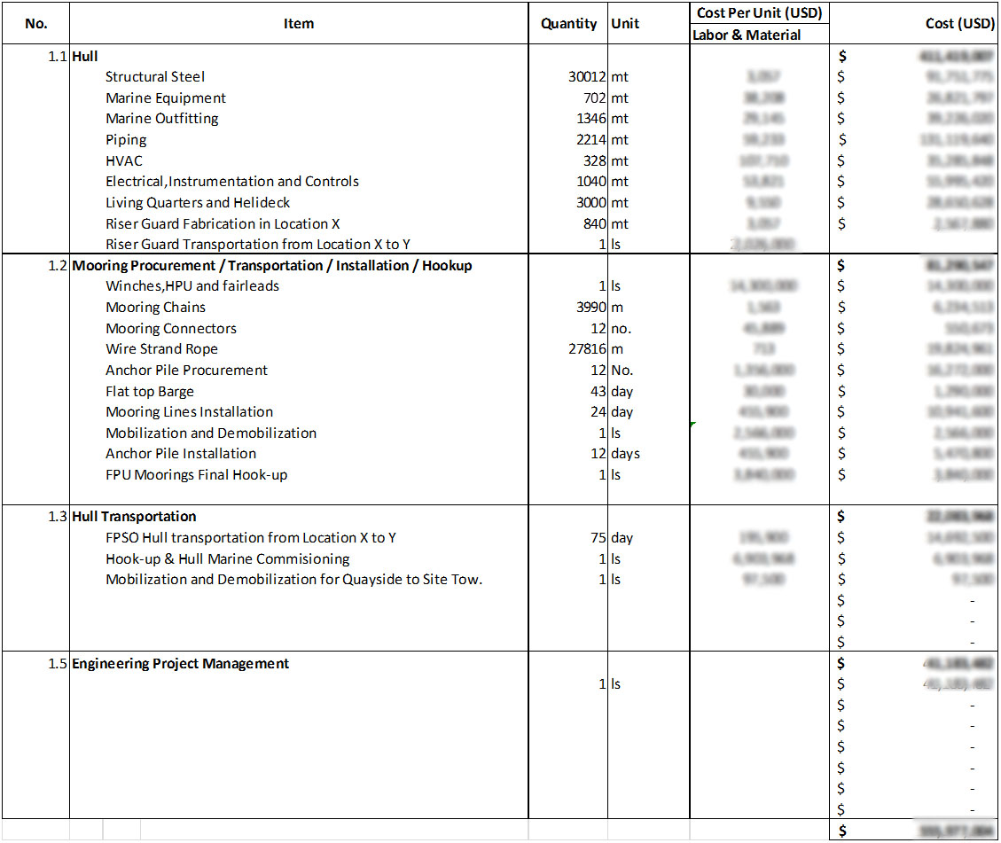

Figure 1. Simplified Approach for FPSO Sizing and Cost Estimation
FPSO Sizing and Cost Estimation

Topsides Capacity
Oil Storage Capacity

Calculate Deck Area

Select Governing Deck Area?

Final FPSO Design Data and Cost
Cost Estimation:
f(Design Data ; Market Rate)
Design Output Data
Hull and Mooring
Calculate depth using cargo hull volume coefficient
Hull Structure Scantlings and Topsides Stool Estimate
Select L/B Ratio
Criteria Check?
Hull Built Type
Topsides Load
Lightship Weight Estimate
Turret Moored
Spread Moored
Mooring Loads
Mooring Design
Turret/Mooring/Riser Loads
Turret Design
Type of Mooring System
Steel Addition
Conversion
New
Stability & Motions
Steel Renewal

